Do you know what your core VALUES are?

It is vitally important to understand our primary and most important values. When you do things, or say things, that are out of alignment with your core values, you are going to feel inauthentic and UNHAPPY. In contrast, when you are living in alignment with your core values, you are more likely to be in harmony, in integrity, and satisfied with your life.

Today’s exercise is from Brene Brown’s book Dare to Lead, which I can’t recommend highly enough. All her work is dedicated to how we can live life in a more wholehearted and fulfilling way.

STEP 1: What are your values?

From the below list, keep narrowing down the list of values until you get to one or two. These are the beliefs that are most important to you, that help you find your way in the dark, that fill you with a feeling of purpose. It’s OK if these values encompass other values on the list in your mind. When selecting your values, ask yourself the following questions:

• Does this define me?
• Is this who I am at my best?
• Is this a filter that I use to make hard decisions?

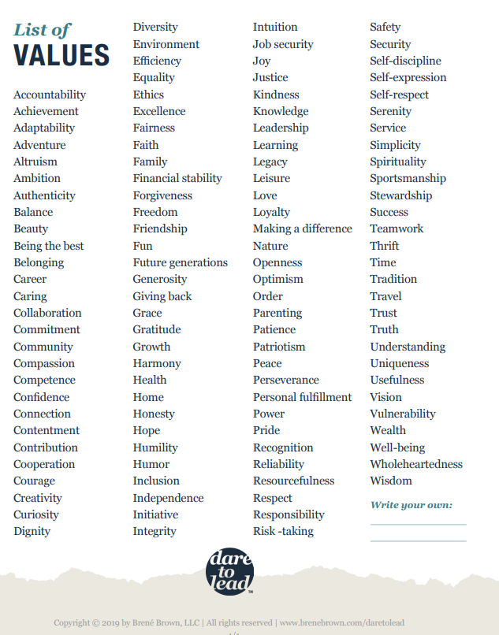
STEP 2: Get practical

Once you have identified your TWO primary values, identify behaviors that will support these values.

What is a physical, behavioral expression of you doing something that is aligned with your values? This will bring awareness to how you can live in alignment with your values. It will help you breathe life into your values so you can live in integrity with them.
- What are three behaviors that support your values?
- What are three slippery behaviors that are outside your values?
- What’s an example of a time when you were fully living into these values?

STEP 3: Putting it into action
Once you have done the exercise, it is time to bring it into your life! Is one of these a word that can set the tone for the year? How can you set these values as your north star? Then, pay attention to the impact living in alignment with your values has on your life.
- Does being aligned with your values fill you with pride?
- Does it allow you to feel more fulfilled?
- Does it make you feel more grounded, centered and at peace?

